Kimberley Dreaming
Houseboat
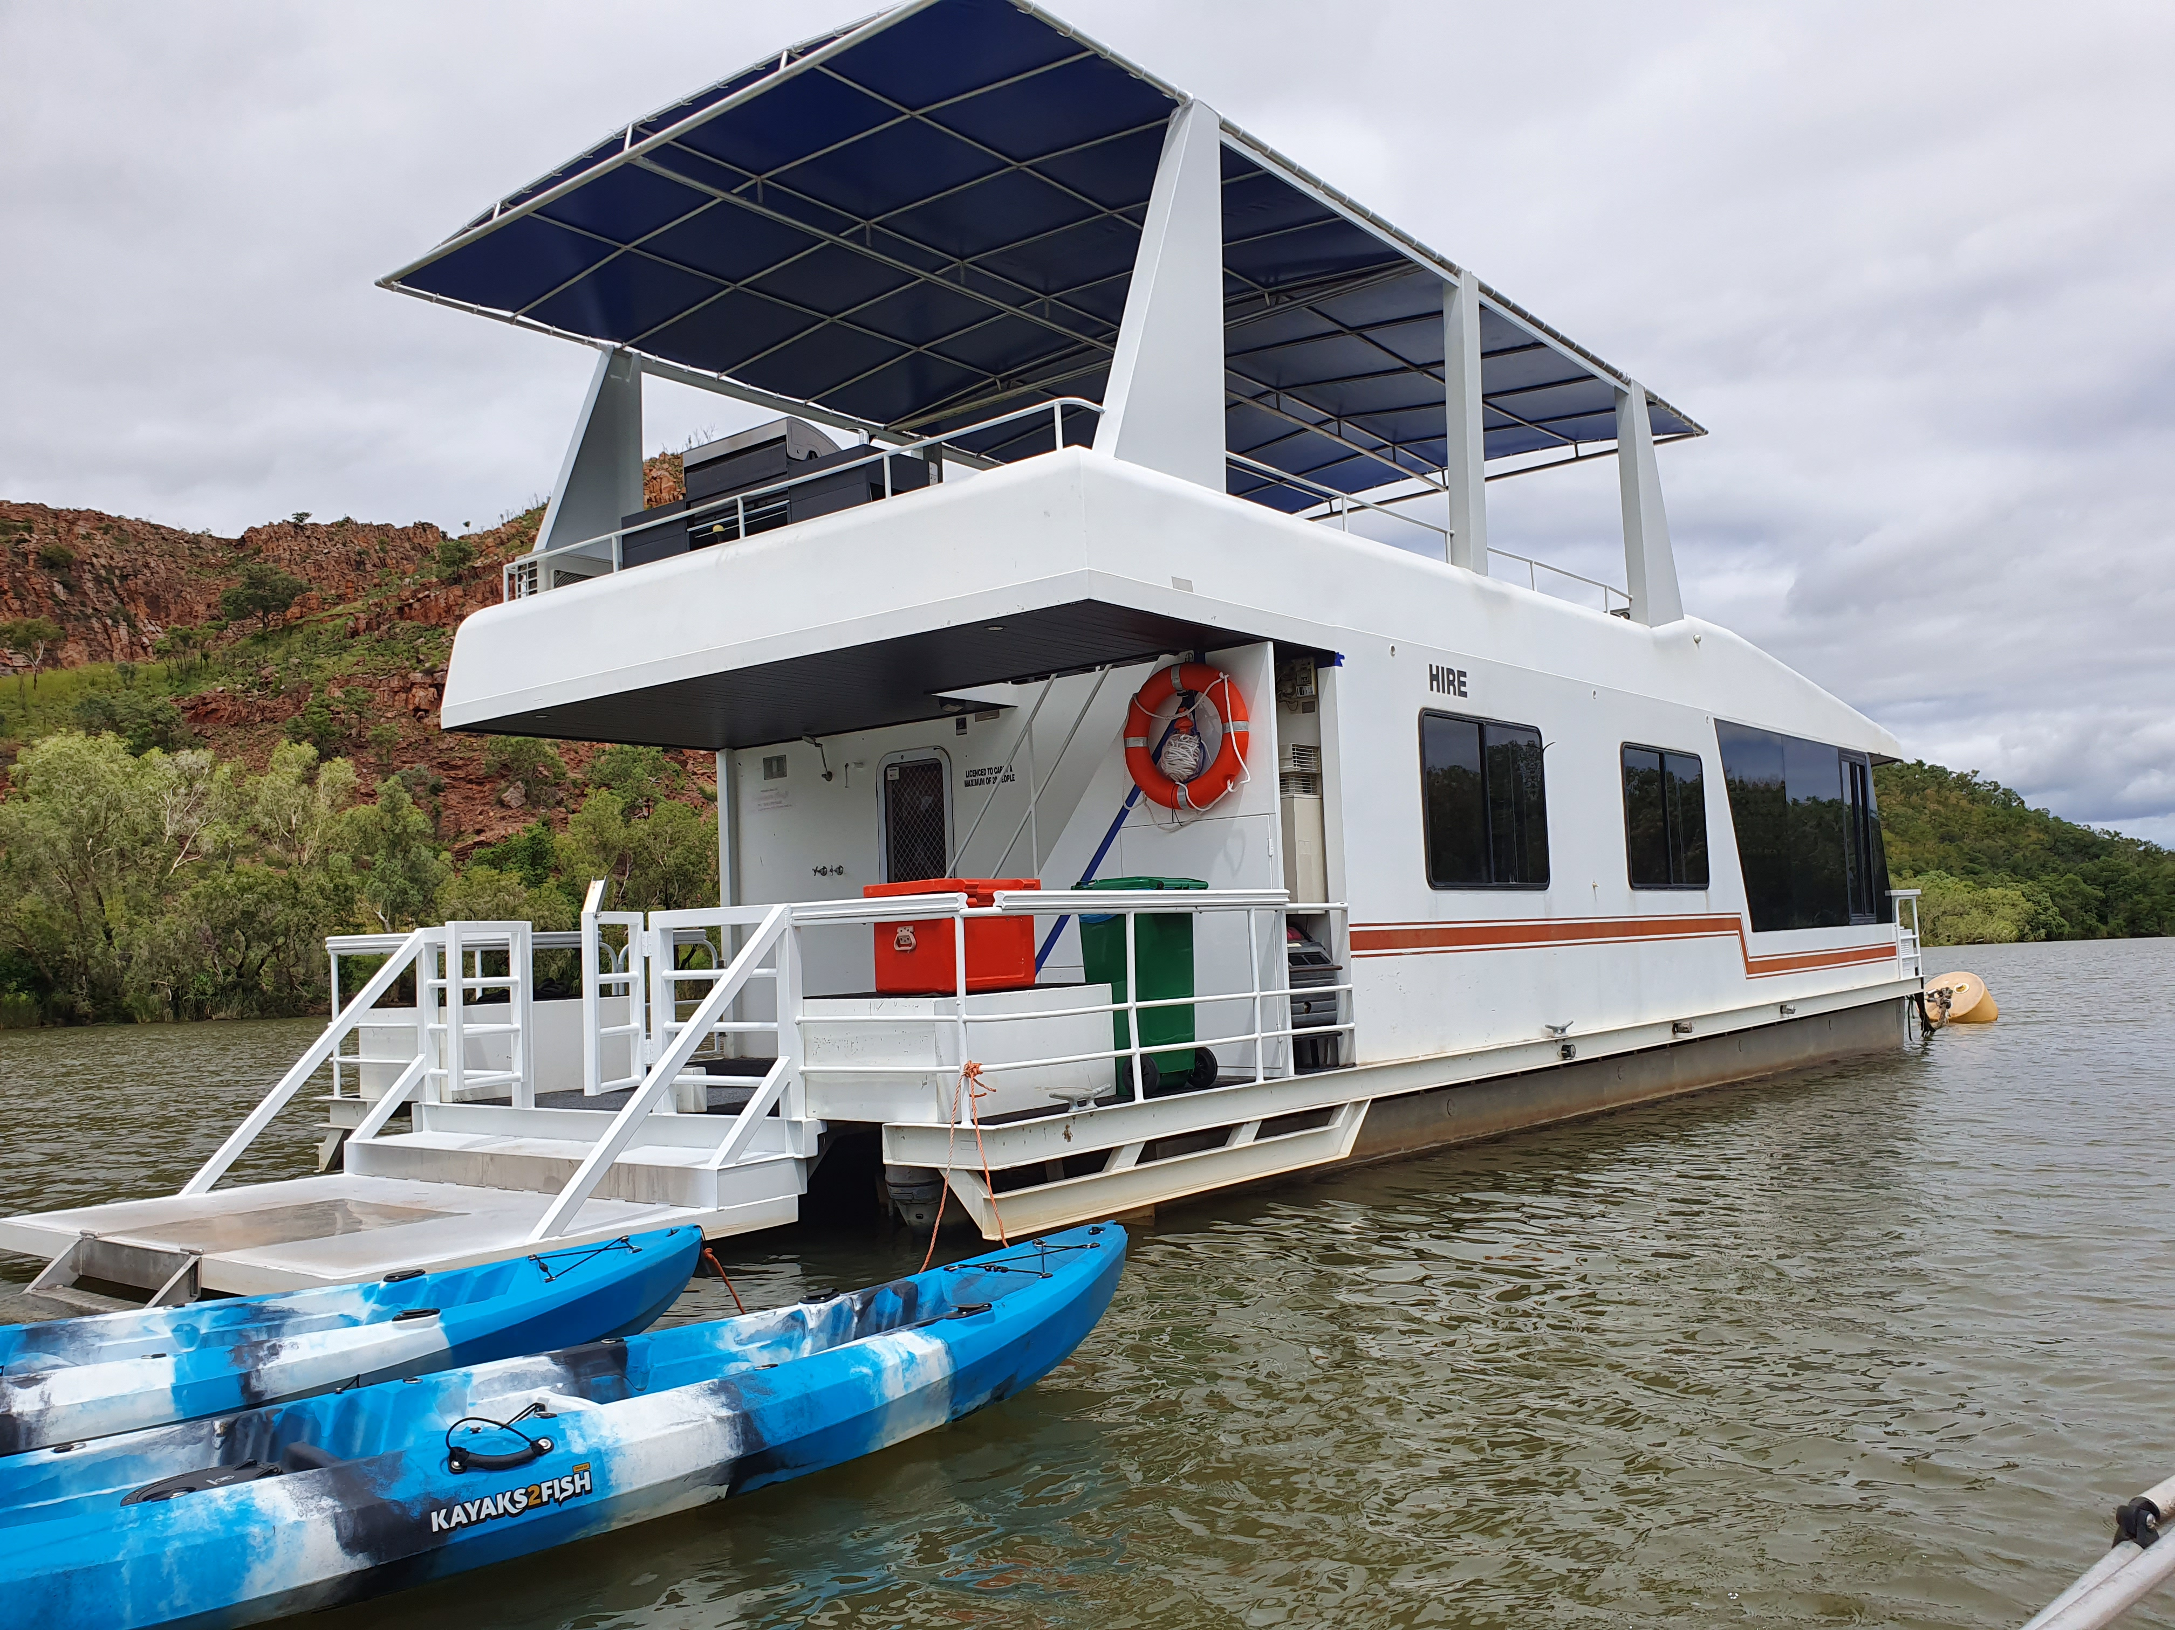

Information Sheet

Thank you for your enquiry regarding Kimberley Houseboats. The following information outlines the equipment on board the vessel, the operational procedures and the key conditions you accept when you hire the houseboat.

On board there is:

- All necessary cooking equipment, inc glassware, crockery and cutlery
- Basic condiments: tea, coffee, sugar, olive oil, salt & pepper etc
There is a coffee plunger so bring your preferred ground coffee
- A standard size refrigerator
- Two 80-litre chest fridge/freezer units on 12V supply
(one to be kept on freeze at all times)
- A three-burner gas stove and a microwave (no oven)
- A 6 burner BBQ on the top deck (with hood for use as an oven) and extra gas ring burner)
- Large screen TV with a selection of movies
- Stereo system with Bluetooth connectivity
- A selection of books, magazines and board games
- Main cabin features a Queen bed
- Second cabin features a double bed and single bunk combo
- A Queen sofa bed/futon in the lounge room
- All linen and bath towels
- Swimming noodles and nets
- 2 double person fishing kayaks
- Tender vessel surveyed for 3 people with electric motor
- All safety equipment and lifejackets (Kids’ life jackets available on request)

You need to bring with you:

- Food and drinks, an extra esky is handy
- Music, extra board games, reading material
- Sunscreen, hats, insect repellent
- Beach towels if swimming
- Torch, camera
- Extra Ice to cover drinks etc

MOORING OPTIONS

The 'Kimberley Dreaming' houseboat is offered to you moored at your choice of locations, and must remain stationary at this location. This is to reduce insurance costs and damage caused to the boat. Only in an emergency situation is the hirer permitted to move the vessel, otherwise you will forfeit your bond.

Lilly Lagoon  “Gourmet Dining” | Wallaby Cliffs  “Enter the Wild” | Sandy Creek  “Wilderness and Gorges'
- Heart of Kununurra  - Secluded in your boat  - Spot Lagoon wildlife  - Stunning Lagoon sunsets  - Paddle or tender to town  for morning coffee  - Access your vehicle for day trips around town  - Bars and gourmet  restaurants accessible by  tender or kayak | - 20km upriver from town  - Edge of the Carr-Boyd  ranges - spot wallabies on the magnificent cliffs  - Explore the Spillway over  flowing from Lake Argyle  - See Archerfish capture  their dinner  - Relax and enjoy the  ambience  - No connectivity -  SAT Phone for emergency | - 30km upriver from town  - Heart of the picturesque  gorge and creek system  - Swim from the rear deck  - Sunbake at Sandy Creek  - Tender or kayak to Jump  Rock  - Water-ski from your dinghy  - Bushwalk to Herbie’s  Hideaway  - No connectivity –  SAT Phone for emergency

GETTING TO THE HOUSEBOAT AND GETTING AROUND
If you choose Wallaby Cliffs or Sandy Creek, Go Wild Adventure Tours will provide transfers from Kununurra to the houseboat in the fast vessel 'Crocadilly' that is surveyed for 12 passengers and is capable of transferring all guests and all the supplies you may need during your time on the Houseboat. The trip will take about an hour. The cost of the transfer is $100 each way and will be deducted from your bond.

For exploring further afield from the houseboat, you may wish to hire our “Whaley” dinghy (Skipper’s ticket compulsory for dinghy hire). Please note that in this case, the transfer will be combined with a river guide service to enable you to navigate from Kununurra town upriver in the dinghy to the houseboat. There are few markings for navigation and local knowledge is needed to navigate upriver. The dinghy is not suitable for transferring you and all your supplies as when fully loaded the dinghy will need at least two hours to reach your destination.

If you have your own boat, the transfer/river guide service must still be accessed unless you can provide evidence of an in-depth knowledge of navigating the Ord River.

The electric tender supplied free of charge with the Houseboat is not ideal to explore the Ord River for any length of time. It can carry three adults and is suitable for shorter trips near the moorings.
The houseboat itself is too big to navigate the upper Ord and the many gorge and creek systems. The fishing kayaks are great for exploring far up into the little creeks which are not accessible to motor boats. Here you will find abundant bird and wildlife undisturbed in their natural habitat.

BE AWARE: If you want to explore further upstream towards Lake Argyle dam wall or venture any distance from the houseboat, you will need your own dinghy or hire the Whaley Dinghy.

COSTS AND PAYMENT INSTRUCTIONS

Hire Rates 2023
Nights | Three | Four | Five | Six | Weekly
Houseboat | $2500 | $2800 | $3100 | $3400 | $3700
Bond * | $1000 | $1000 | $1000 | $1000 | $1000
WHALEY DINGHY: $100 per day SKIPPERS TICKE T MUST BE SHOWN AT PICKUP

* Deductions from Refundable Bond include:
- Transfers in fast 7m vessel: Kununurra - Houseboat location ($100 – per trip as required)
- Additional Fuel for generator for air conditioner – 240v power supply
- Damages to Houseboat or equipment or Whaley dinghy if applicable
- Cleaning Fee if Houseboat is left in an unacceptable condition

Please note the Hirer must sign a Conditions of Hire contract after the safety induction. Important conditions to note include:

- Bookings are made on our website - kimberleyhouseboats.com
- Bookings are confirmed via the website online payment of a $500 deposit.
- Please note that you booking is not confirmed until the deposit is paid.
The remainder of the total fee, plus the $1000 bond and the fee for the Whaley Boat hire is payable approximately 10 days prior to date of departure.
Total cost including the bond is shown as you book on the website and can be paid at the time of booking if desired
We reserve the right to apply a higher bond for large group hires.
- The bond is refundable minus costs for extra fuel, transfers, extra cleaning fees and any damages
- Cancellations Policy: Cancellations made less than 30 days prior to departure, will forfeit the deposit of $500. Covid related cancellations can be made up to 48 hours before departure only when a government-imposed border lock down is imposed.
- All hires start with a complimentary generator full of fuel. Additional fuel used from the 3 jerry cans provided aboard is calculated after your hire (at the pump price of the day/Litre) and deducted from the Bond.
- Standard check-in time is 1.00 pm and check-out time is 9.00 am. These times are not guaranteed and may vary with each hire. Check-in and check-out times will be confirmed just before your hire date. We will offer early check-in and late check-out whenever possible.
- ON DAY OF ARRIVAL - You must be ready to leave the Kununurra Town Jetty no later than 1pm. This ensures that there is time for your transfer, induction and for the transfer boat to return to Kununurra before dark which is around 5pm.
Thus, if your flight or other means of transport to Kununurra, does not arrive in time for you to do your shopping and be at the jetty by 1pm, you will need to spend the night preceding your Houseboat booking in accommodation in Kununurra.
- The houseboat is licensed to carry 18 people for safety reasons (suitable for day hire functions), but is only licensed to sleep six people overnight. This is a requirement of survey with AMSA and is illegal to contravene.
- The houseboat must remain stationary at the mooring destination that you have chosen. Only in an emergency can those hiring the houseboat move it or drive it, otherwise you will forfeit your bond.
- Please report any damage to the houseboat (or other infrastructure) to us on check-out.
- Please report any damaged or missing items on the houseboat. We unfortunately lose a steady stream of towels, cups, chairs, glasses, noodles etc, making it difficult for us to keep the houseboat fully equipped.
- We reserve the right to deduct costs incurred from damage or loss to the houseboat or its contents by the Hirer from the bond.
- All water used on board is stored in a sullage tank. Please be conservative with water use and do not leave any taps running. A full tank will result in blocked plumbing, including the toilet, and an unpleasant holiday!
- Please leave the houseboat in a tidy state, with the BBQ cleaned. Three hours of standard cleaning is included in your hire fee. Any excessive cleaning will be charged at an hourly rate ($75 per hour) and deducted from the bond.
- Please keep the downstairs fridge/freezer set to freeze. The 12v solar system will not recover and refreeze before the next guests arrive meaning they will be unable to store their frozen goods.

Please note that Liquor Restrictions do exist in Kununurra and take away alcohol can only be purchased after 12 noon, in limited quantities, and not at all on Sundays.

Please email us at Go Wild Adventure Tours info@gowild.com.au
or hagan@iinet.net.au
or contact Maka on 0409456643
or Jacque on 0407225107
if you have any questions.

Further information is available on our Facebook page.
www.facebook.com/kimberleyhouseboats

We are happy to answer any questions and provide advice for customers planning their holiday on the Ord River in the fabulous East Kimberley.

